SAILING INSTRUCTIONS

2024 Admella Cup Match Racing Regatta Friday 12th April– Sunday 14th April Hosted by the Portland Yacht Club.

Abbreviations
PC - Protest Committee RC - Race Committee OA - Organising Authority
NA - National Authority RRS - Racing Rules of sailing SI – Sailing Instructions
NoR Notice of Race PYC - Portland Yacht Club

- ORGANISING AUTHORITY
  - The Organising Authority (OA) is Portland Yacht Club

- Schedule
Friday 12th April | 1700-1900  1800 | Practice sail  Corkies Bar open and Burgers or BYO dinner
Saturday 13th April | 0830  0900  1000 | Skippers check in  Briefing  Racing starts
Sunday 19th | 0900  1600  ASAP after racing | Briefing  1000 Racing starts  No race to be made after this time  Presentations

- RULES
  - The event will be governed by;
    - the ‘rules’ as defined in the RRS, including Appendix C.
    - the rules for Handling of Boats (SI Appendix C). Class rules will not apply.
    - any prescriptions of the NA that will apply will be posted on the official notice board.
    - When the umpires proceed under RRS C8.6 they will follow the guidance in SI Appendix E.

- SAFETY
  - All Race Officials, Volunteers, Maintenance, Coaches, Media, Guests, and Participants that operate a power boat during the regatta are reminded to wear a kill cord and be vigilant on the designated VHF radio channel.
  - all Race Officials, Volunteers, Maintenance, Coaches, Media, Guests and Participants shall wear a PFD whilst on a vessel.

- ELIGIBILITY AND ENTRIES
  - Each skipper must enter online at portlandyachtclub.com.au and pay the entry fee and bond.
  - Each skipper is responsible for any damage or loss to their boat unless the responsibility is otherwise assigned by the umpires or PC.
  - After the warning signal for a match, the registered skipper shall not leave the helm, except in an emergency
  - When a registered skipper is unable to continue in the event, the OA may authorise an original crew member to substitute.
  - When a registered crew member is unable to continue in the event, the OA may authorise a substitute, a temporary substitute or other adjustment.

- COMMUNICATIONS WITH COMPETITORS
  - Notices to competitors will be posted on the official notice board located in the Portland Yacht Club
  - Signals made ashore will be displayed from the flag mast of the PYC clubhouse
  - Skippers will be issued with VHF radios. These radios shall be used only to make and receive communications from the RC or to report any damage. Failure to receive information from the RC will not be grounds for redress. This changes RRS 62.1(a).

- AMENDMENTS TO THE SAILING INSTRUCTIONS
  - Amendments to the SI made ashore will be posted at least 30 minutes before the start of any race affected and will be signed by the RC and PC representatives.

- BOATS AND SAILS
  - The event will be sailed in SB 20 boats provided by PYC
  - The mainsail and Jib to be used will be allocated by the OA and shall remain on each boat for the duration of the event. Sails may be substituted by the OA in the event of damage, loss, or for any other reason that the OA may deem appropriate
  - The sail combination to be used will be mainsail and jib only.

- IDENTIFICATION AND ASSIGNMENT OF BOATS
  - Boats will be identified by numbers on the bow.
  - Boats will be allocated by the RC.
  - The selection of boats shall not be grounds for redress. This changes RRS 62.1.

- CREW MEMBERS
  - As per NoR 9.

- EVENT FORMAT AND STARTING SCHEDULES
  - The event format is detailed in SI Appendix B
  - The competitor list, pairings and boat allocation will be issued at the briefing.
  - In a final series between two skippers:
    - The higher-placed skipper from the round robin shall have the starboard entry for the first match. They shall thereafter alternate assigned ends
  - The intended time of the first attention signal is 1000 with the latest time for a warning signal approximately 1600 on Sunday 14th April.
  - The RC may change the format, terminate any stage or the event when, in its opinion, it is impractical to attempt to hold the remainder of the matches under the existing conditions or in the remaining time scheduled. Early stages may be terminated in favour of later stages.

- RACING AREA
  - The racing area will be Harbour in Portland Vic in front of PYC

- COURSE
  - (a) Course Configuration (not to scale)
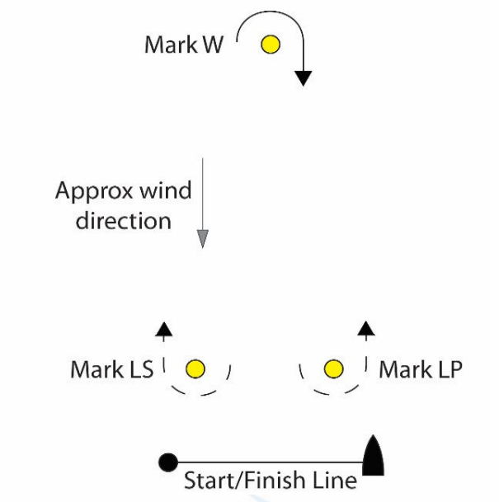
(b) Course Start – W – LS or LP – W – Finish
(c) Descriptions of Marks
The RC vessel will be identified by an orange flag. The starting/finishing line mark will be a white mark or other specified at the briefing. Marks W, LS and LP will be teardrop marks. The mark colours will be advised at the briefing.
  - Starting/Finishing Line
The starting and finishing lines will be a straight line between the course side of the starting and finishing marks and the flag mast on the RC vessel displaying an orange flag. Boats are permitted to sail through the Starting/Finishing line.
  - Course Limits
    - While racing, no part of a boat's hull shall sail inside the imaginary straight line between the ends of the marina jetties.
    - These imaginary lines shall rank as obstructions and are the limit of safe pilotage for the purposes of Part 2 of the RRS.
    - A breach of this sailing instruction is not open to protests by boats but is subject to action by the umpires in accordance with RRS C8.2. This changes RRS C6.2 and C8.2
  - Abandonment and Shortening
    - RRS 32 is deleted and replaced with: “After the starting signal the RC may abandon or shorten any match for any reason, after consulting with the match umpires when practical.”
    - Abandonment of a match that has started will be signalled by an official vessel displaying flag ‘N’ or by the match umpires approaching the two boats concerned and hailing. This alters Race Signals
    - The course may be shortened after the start whilst boats are in the general vicinity of Mark W. A shortened course will be signalled by a RC vessel approaching the two boats concerned, displaying flag S and making a repetitive sound signal. Boats shall proceed to the finish at the starting/finishing line rounding Mark W if they have not already done so. This alters Race Signals ‘S’.
- BREAKDOWN AND TIME FOR REPAIRS
  - Before the attention signal of a flight or within two minutes of finishing or within 5 minutes of changing into a new boat, whichever is later, a boat may display a green flag to signal breakdown or damage to the boat, her sails or injury to her crew and request a delay to the next start. She shall proceed as soon as possible to the starboard side area of the RC start vessel and remain there unless otherwise directed.
  - The time allowed for repairs shall be at the sole discretion of the RC.
  - After the attention signal of a flight, a match will not be postponed or abandoned due to breakdown unless the breakdown signal was displayed as required by SI 13.1.
  - Except when RRS 62.1(b) applies, failure to effect repairs in the time allowed, or breakdowns after the attention signal shall not be grounds for redress. This changes RRS 62.

- STARTING PROCEDURE
  - Starting signals will be made in accordance with rule C3.1 except that the table of signals is changed to the following:
Time to start  (minutes) | Visual Signal | Sound Signal | Means
4 | L Flag | one | Attention signal
3 | Num pen 1 Displayed.  L Flag removed | one | Warning signal – pre-start entry
2 | Num Pen 1 displayed.  Blue P Displayed | one | Preparatory signal – end of pre-start entry time.
1 | Num Pen 1 Displayed  Blue P removed | one | 1 minute
0 | Num Pen 1 removed | one | Starting signal

- TIME LIMIT
  - A boat that does not finish within 5 minutes after her opponent has completed the course and finished will be scored DNF. This changes RRS 35 and A5

- MEDIA, IMAGES AND SOUND
  - The OA shall have the right to use any images and sound recorded during the event free of any charge.

- PRIZES
  - 1st place will be awarded the Admella Porthole and $300

- CODE OF CONDUCT
  - Competitors shall comply with any reasonable request from any official, including attendance at official functions, and cooperation with event sponsors and shall not behave so as to bring the event into disrepute.
  - Competitors shall handle the boats and equipment with proper care and seamanship and in accordance with SI Addendum C and D.
  - The following actions by skippers and/or crew while racing may be considered a breach of sportsmanship under RRS C8.3(c) and may result in an umpire-initiated penalty under RRS C5.2 or C5.3:
- Excessive attempts to verbally coerce, coach or influence umpire decisions,
- Repetitive or on-going objection to an umpire decision (verbal or otherwise),
- Abuse of umpires before or after a decision.

- DISCLAIMER
  - All those taking part in this event do so at their own risk and responsibility. Portland Yacht Club their officials and volunteers and any other associated sponsor or guest disclaims any and every responsibility for loss, damage, injury or inconvenience that might occur to persons and things both ashore and at sea, as a consequence of participation in any way in this event. Attention is drawn to RRS Part 1, Fundamental Rules, in particular, the RRS 3 which states that: “The responsibility for a boat’s decision to participate in a race or to continue racing is hers alone.”

APPENDIX A – ELIGIBLE SKIPPERS & PAIRING LISTS

Pairing list, Eligible skippers and boat allocations will be issued at the briefing.

APPENDIX B – EVENT FORMAT

Stage 1 – Round robin
All skippers will sail a round robin – each skipper sails each of the other skippers an equal
amount of times. The two highest scoring skippers will go to Stage 3 the next two highest scoring skippers will go to stage 2.

Stage 2 – Petit Final
The first skipper to score two points will be awarded third place, the other fourth place.

Stage 3 – Final
The first skipper to score 3 points will be awarded 1st place, the other second place.

APPENDIX C – HANDLING BOATS

- GENERAL
  - While all reasonable steps are taken to equalise the boats, variations will not be grounds for redress.

- PROHIBITED ITEMS and ACTIONS
Except in an emergency, to prevent damage or injury, or when directed by an umpire or the RC otherwise, the following are prohibited:
  - Any additions, omissions or alterations to the equipment supplied.
  - The use of any equipment for a purpose other than that intended or specifically permitted.
  - Replacement of any equipment without the sanction of the RC.
  - Sailing the boat in a manner that it is reasonable to predict that significant further damage would result.
  - Moving equipment from its normal stowage position except when being used.
  - Boarding a boat without prior permission.
  - Taking a boat from its berth or mooring without having paid the required bond or having permission from the RC, or on race days, prior to one sound signal being made by the RC or while "AP" is displayed ashore
  - Hauling out a boat or cleaning surfaces below the waterline.
  - Perforating sails, even to attach tell tales.
  - Adjusting tensions to battens in the mainsail.
  - Adjusting or altering the tension of standing rigging, excluding the backstay.
  - Marking or writing directly on the deck or hull with permanent pens.
  - The use of electronic instruments (including portable radios and telephones) other than watches and VHF radios to the extent permitted in SI 5.3.
  - After the starting signal and while sailing close hauled for more than a few seconds, the main boom position shall be controlled only by using the mainsheet as it exits the block on the cockpit floor and the vang.

- PERMITTED ITEMS and ACTIONS
Taking on board and making appropriate use of the following:
  - Adhesive tape
  - Line (elastic or otherwise of 4 mm diameter or less)
  - Tell-tale material
  - Hand-held compasses, watches, timers, and small personal video devices such as GoPro
  - Spare flags
  - PFD’s

- MANDATORY ITEMS AND ACTIONS
The following are mandatory:
  - The completion of a written damage report in case of any damage.
  - At the end of the day:
    - Folding, bagging and placement of the sails as directed
    - Leaving the boat in the same state of cleanliness as when first boarded that day
    - Cleaning the boat (cabin and decks), removing all trash, tape and marks including sponsorship signage, if directed.
    - Returning any damaged sails to the PYC shed
    - Any request to alter, in any way, the equipment on a boat shall be directed in writing to the RC and worded to permit a yes/no answer.

Appendix D – Equipment list

The following non-fixed items, provided by the OA, are to be carried on board at all times in their designated place while sailing. Any loss shall be reported on the daily damage report.
- SAILS AND SAILING EQUIPMENT
- Mainsail and set of battens
- Jib
- Sail bags
- Two jib sheets
- Tiller extension
- One VHF radio

APPENDIX E – Penalties for damage resulting in contact between boats when racing.

Appendix C6.6 and C8.6 permits the umpires or protest committee to decide the penalty when a boat breaks RRS 14. This document explains how damage will be assessed and gives general guidance on the appropriate penalty. When the protest committee has good reason to do so, it may apply a different penalty
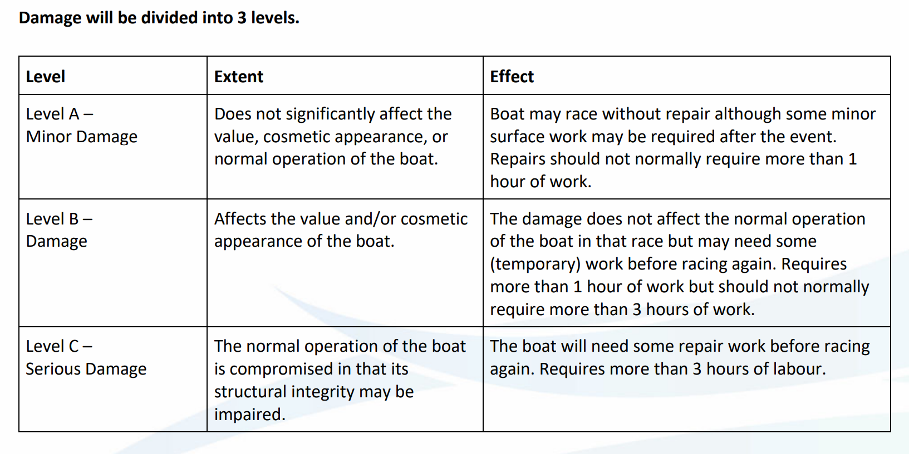
Point Penalties - to be applied without a hearing (as per Appendix C8.6)
Level | Penalty
A | None
B | Half point
C | One point
When both boats break RRS 14, they should both receive a points penalty. If a competitor requests a hearing after a points penalty has been imposed, the protest committee may decide (in the hearing) to give a greater penalty.
Deductions from Damage Deposit
The assessment of damage level is only for the purpose of points penalties and is not linked to any deductions from the competitor’s damage deposits. Any points penalty will be assessed on the assessment of damage level made on the water. Subsequent assessments of damage level after closer inspection, whether the level turns out to be higher or lower, will have no effect on the points penalty given on the water. Monetary deductions are assessed separately after closer inspection by the OA ‘boat person’, and all damage costs are deducted from damage deposits irrespective of any penalty (or none) imposed under this system.

Event sponsor

